Shared Risk

Establish a Network Guide
<Network Name>
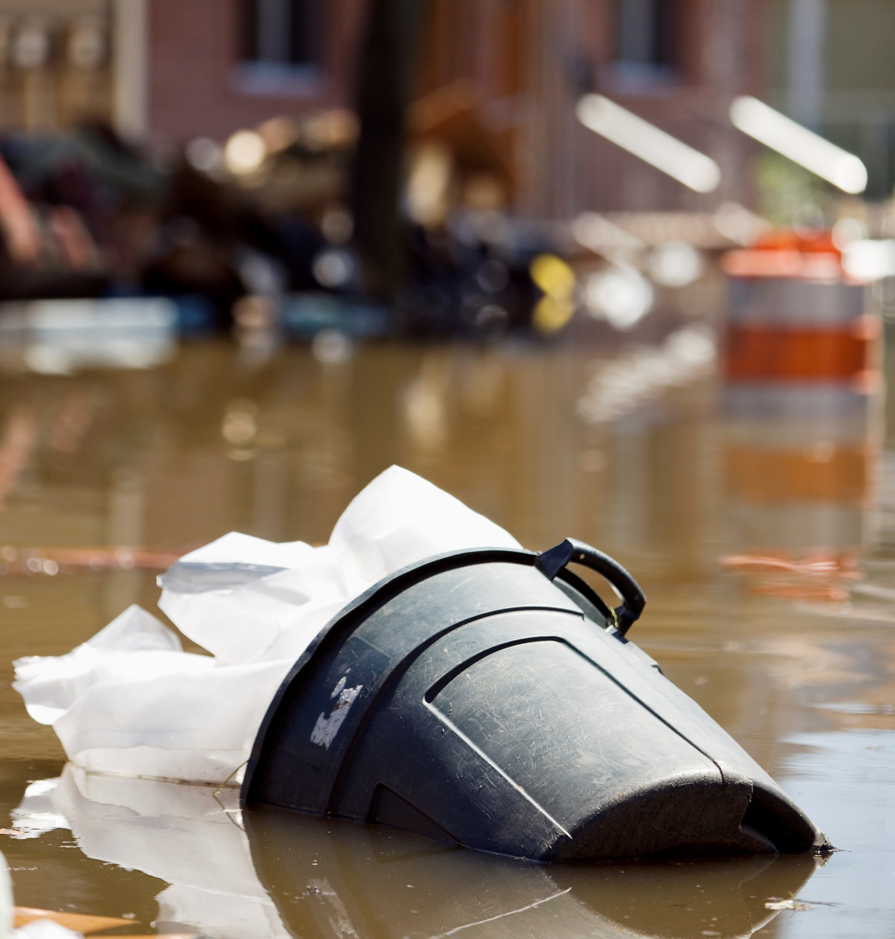
DD Month 20XX
Contents
Introduction 3
The Four Phases of the Network Approach 4
Phase 1 - Plan 4
Phase 2 - Build 5
Phase 3 – Identify & Review 5
Phase 4 - Sustain 6
Considerations for Working Together 7
Setting up the Network 7
Coordination, Cooperation or Collaboration? 7
Co-create Values and Cultural DNA 8
Communication 8
Diversity of Capabilities 8
Adaptability 9
Creative Freedom 9
The Network Agreement 9
More Information 9

Introduction
This guide can be used as a reference for building and maintaining a network to manage shared risk.
The first section takes your through the phases of the network approach, breaking down the different options at each step into the actions required and highlighting the resources available.
The second section explores different considerations of working together, focussing on what will enhance the likelihood of the network achieving its goals.
The final section introduces the Network Agreement and where you can go for more information.

Other shared risk documents
- Practical Guidance for Managing Risk https://www.vmia.vic.gov.au/tools-and-insights/practical-guidance-for-managing-risk

The Four Phases of the Network Approach
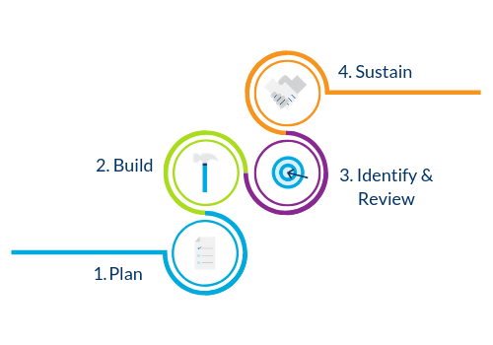

Phase 1 - Plan

a) Stakeholder Mapping Workshop
Option | Reason | Actions | Resources
Stakeholder Mapping Workshop | If assistance is needed to identify stakeholders | Facilitate Stakeholder Mapping Workshop | Stakeholder Mapping Workshop:  - Facilitator Guide  - PPTs

b) Consult stakeholders
Option | Reason | Actions | Resources
Consultation | Simple network | - Brainstorm stakeholders  - Complete the Stakeholder List | Stakeholder List template

c) Set up Network Governance
Option | Reason | Actions | Resources
Consultation | Complex networks | Complete Network Agreement | Network Agreement template

Phase 2 - Build

a) Establish network
Option | Reason | Actions | Resources
Consultation | Simple network | Send Establish a Network Guide members | Establish a Network Guide (this document)
Establish a Network Workshop | Complex network | Facilitate Establish a Network Workshop | Establish a Network Workshop:  - Facilitator Guide  - PPTs

Phase 3 – Identify & Review

a) Identify or validate risks, controls and treatments
Option | Reason | Actions | Resources
RIMP Workshop | Identify or validate strategic risks | Facilitate RIMP Workshop | Risk Identification & Management Program (RIMP):  - Facilitator Guide  - PPTs

b) Distribute risks controls and treatments
Actions | Resources
Distribute risks, controls and treatments to members of the network.

c) Send out first Pulse Check
The Initial Pulse Check will serve as a “go or no-go”
Actions | Resources
- Distribute the Initial Pulse Check  - Collate responses  - Assess whether the network is ready to commence | Initial Pulse Check

d) Review risks/controls as required

Phase 4 - Sustain

a) Maintain collaboration, information sharing and ongoing risk management tasks
Actions:
- Reporting
- Information sharing
- Consider new stakeholders
- Progress
- New risks
- Changes to legislation

b) Ongoing Pulse Checks
Actions | Resources
- Distribute the Ongoing Pulse Check  - Collate responses and action if necessary | Ongoing Pulse Check

Considerations for Working Together
This section includes different aspects of working together in a team or network. Every network is different and so will have different needs around what might work in terms of working together.

Setting up the Network
- Establish clear terms of reference/charters including the purpose and role of the network, the responsibilities of its members, and its accountability to (or degree of independence from) the lead agency
- Select the right members for the task—whether representative or related to expertise equip network members with the skills and resources they need to play an active role in network deliberations
- Ensure briefing papers are sent out in a timely manner so that all members have the opportunity to consider them thoroughly
- Review network performance and appropriateness on a regular basis, particularly when the functions of the organisation change
- Ensure the network remains strategically focused, aligned and integrated—developing a work plan for the year ahead can assist with this

Coordination, Cooperation or Collaboration?
When managing shared risk, consider how you want to work with the other agencies:
- Coordination: Let’s achieve a common activity:
- Shared interests
- Harmonious relationship
- Defined processes and patterns
- Decisions and power remain with each individual organisation
- Cooperation: Let’s improve something
- Sharing ideas as a group
- Independent activities
- Shared goals
- Decisions and power are generally with the parent organisation/lead agency
- Often short term
- Collaboration: Let’s create something new and unanticipated
- Required when dealing with the unknown, and with divergent points of view
- Required when dealing with complex situations or risks
- An environment where ideas are encouraged, can be shared, can evolve (add, edit delete the content)
- Co-creation, with mutually negotiated rules
- Various outcomes, both expected and unplanned
- Decisions and power are shared between organisations

Co-create Values and Cultural DNA
One of the most important factors in bringing network together is co-creating core values with your members - what makes the network unique, what defines and inspires your network?
When developed in a thoughtful and intentional way, values can help members concentrate on delivering better results. Make your values authentic. Once you have the values in place, map those values, as well as the network’s priorities and goals into a solid plan so the team can internalise and act. With clear goals and outcomes in mind, everyone can pull in the same direction, and know how their work in managing risk contributes to those goals.

Communication
Good communication skills are integral to any network’s success. Here are some ways to assist with communication across the network.

Achievable goals
Good communication is the crucial component of making goals reachable. By using a central governance document (see the Network Agreement), expectations are clear to all the participants, and work is divided fairly based on each person's unique strengths and qualifications. This means nobody has to be responsible for or able to do everything. Clear communication makes these things evident so that deadlines are less stressful, and objectives are met.

Greater efficiency
When each network member knows his or her role in managing the shared risk, all are free to focus on only their own tasks, without worrying about what everyone else is doing. Clear communication also means communicating with network members when you are not able to complete your tasks, so the network can come up with solutions before the situation escalates. Communication helps you maintain efficiency under a variety of circumstances and conditions.

Positive work relationships
These communication skills foster trust between network members, and this creates an environment for positive professional relationships to take root and grow. When network members know each other well, they become acquainted with each other’s strengths, weaknesses, tendencies and thought processes, which makes it easier to work together toward a common goal and plan for future projects. Positive work relationships add a sense of fulfillment and satisfaction in the network and ensure the sustainability of the network.

Creating a culture of celebration
Good network communication skills are not simply about assigning tasks or troubleshooting problems. Communication is also about creating a culture of celebration in the workplace. Network members who notice achievements of their peers take the time to communicate and celebrate together. Improvement is noticed, congratulated and encouraged, as well, which creates an environment where members want to be their best on the job and maintain a growth mindset.

Diversity of Capabilities
Networks that possess a wide range of professional competencies can be more fully equipped to meet a wide range of challenges. When building a network, ensure that there is a varied range of skills and strengths that complement the skills, strengths and weaknesses of other network members is a that each team member possesses Bringing together people with common skill-sets can lead to a great deal of discussion with little subsequent action. Ensuring that each network member possesses a unique specialty allows team members to trust each other for certain aspects of performance, while fully understanding what their own contribution is expected to be.

Adaptability
High-powered networks must be flexible and adaptable to changing conditions. Network strategies, goals, tasks, workflows and even members can change over the life of the network. Network members should be able to rally together and meet new challenges head-on, rather than splintering into ideological factions or banding together to resist change. Change is an unavoidable part of modern business, and the most effective teams can roll with the punches and change the way they work together.

Creative Freedom
All network members should feel free to think creatively--to try new things and fail without the fear of consequences. This aspect of teamwork brings together all the other elements for effective teamwork. Network members must trust that others will listen openly to their ideas, they must be able to confidently and openly communicate their new ideas, they must be trusted enough in their area of expertise to lead the way in new initiatives and they must be adaptable enough to accommodate the changes inherent in bringing new ideas to realisation.

The Network Agreement
The Network Agreement is a template that you and your network may choose to use. It is particularly recommended for complicated and complex types of shared risks.
It helps you define, identify and record important information about the shared risk, the indicative budget allocated to deal with the risk, roles and responsibilities, how you will monitor and govern the risk and the ways you will work together with other agencies and organisations.
Importantly, it also includes a sign off page to obtain written commitment from the relevant parties.

More Information
VGRMF Resources | https://www.vmia.vic.gov.au/tools-and-insights/practical-guidance-for-managing-risk
VMIA | Your Risk Adviser

