Risk management communication plan

Purpose and Outcomes

    - This tool provides you with information, examples, and templates on how to communicate risk internally and externally. Using this, you can create your own risk management communications plan. A stakeholder is defined as Person or organisation that can affect, be affected by, or perceive themselves to be affected by a decision or activity.
 | © State of Victoria 2021  You are free to re-use this work under a Creative Commons Attribution 4.0 licence, provided you credit the State of Victoria (Victorian Managed Insurance Authority) as the author, indicate if changes were made and comply with the other licence terms. The licence does not apply to any branding, including Government logos.  © Victorian Managed Insurance Authority 2021 | Victorian Managed Insurance Authority (VMIA) acknowledges the Traditional Custodians  of the land on which we do business and we  pay our respects to Elders past, present and emerging. We acknowledge the important contribution that Aboriginal and Torres Strait  Islander peoples make in creating a thriving Victoria.

Considerations and support
- Consideration | - Questions to ask | - Support materials / information
Presenting the plan | What’s our style of presenting information?  What level of detail do we need in a communication plan? | Refer to your style guide and/or branding guidelines
Choosing how we’ll communicate | What is our risk management communication approach?  What types of communication do we need to include? | Social media / newsletter  Email  Regular risk reports produced for the executive, board, projects teams or other stakeholders  Periodic risk identification / awareness workshops  Articles included in intranet, emails etc  Presenting at key forums  Risk management messages in annual report  Delivering training including induction / orientation programs
Identifying our audience | Who are our stakeholders and audience (internal/external) for communications? | Board  CEO  People leaders  Project team(s)  Risk Champions  All staff  Specific department or division
Frequency | How often should messages be sent?  What’ll be the most beneficial frequency to issue communications?  Find clear air: what other corporate messaging campaigns are happening?
Approvals | Who needs to approve communications before they are distributed? | CEO  People leaders

Stakeholder Analysis

Stakeholder analysis typically refers to techniques or tools to identify and understand the needs and expectations of major interests inside and outside of your organisation. Use the matrix below to help identify stakeholders and determine their level of interest in your risk management approach. This will help you work out the level and frequency of engagement.
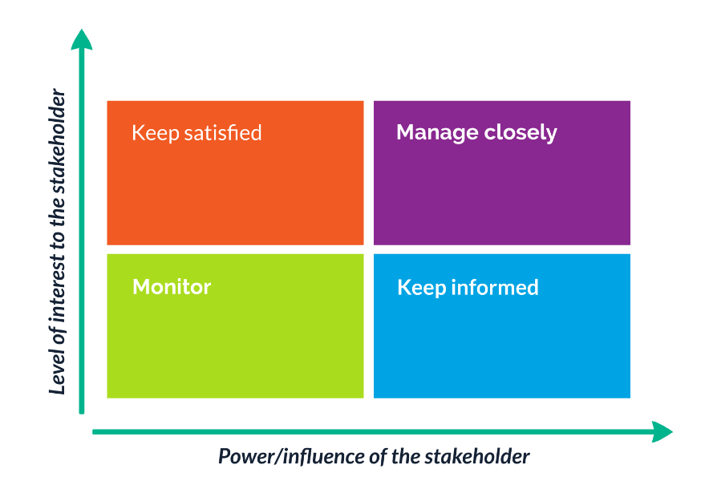

Risk Management Communication Plan
Stakeholders | Purpose | Message/content | Channel/method | Timing/date | Frequency | Prepared by | Sent by | Status
Internal
Board (incl Audit & Risk Committee)
CEO
People leaders
Project team(s)
Risk Champions
All staff
Specific departments/division
External
Clients
Business partners / suppliers
Other departments
Other institutions
Ministers
Community organisations
Media

