Facilitator Guide for VMIA Clients
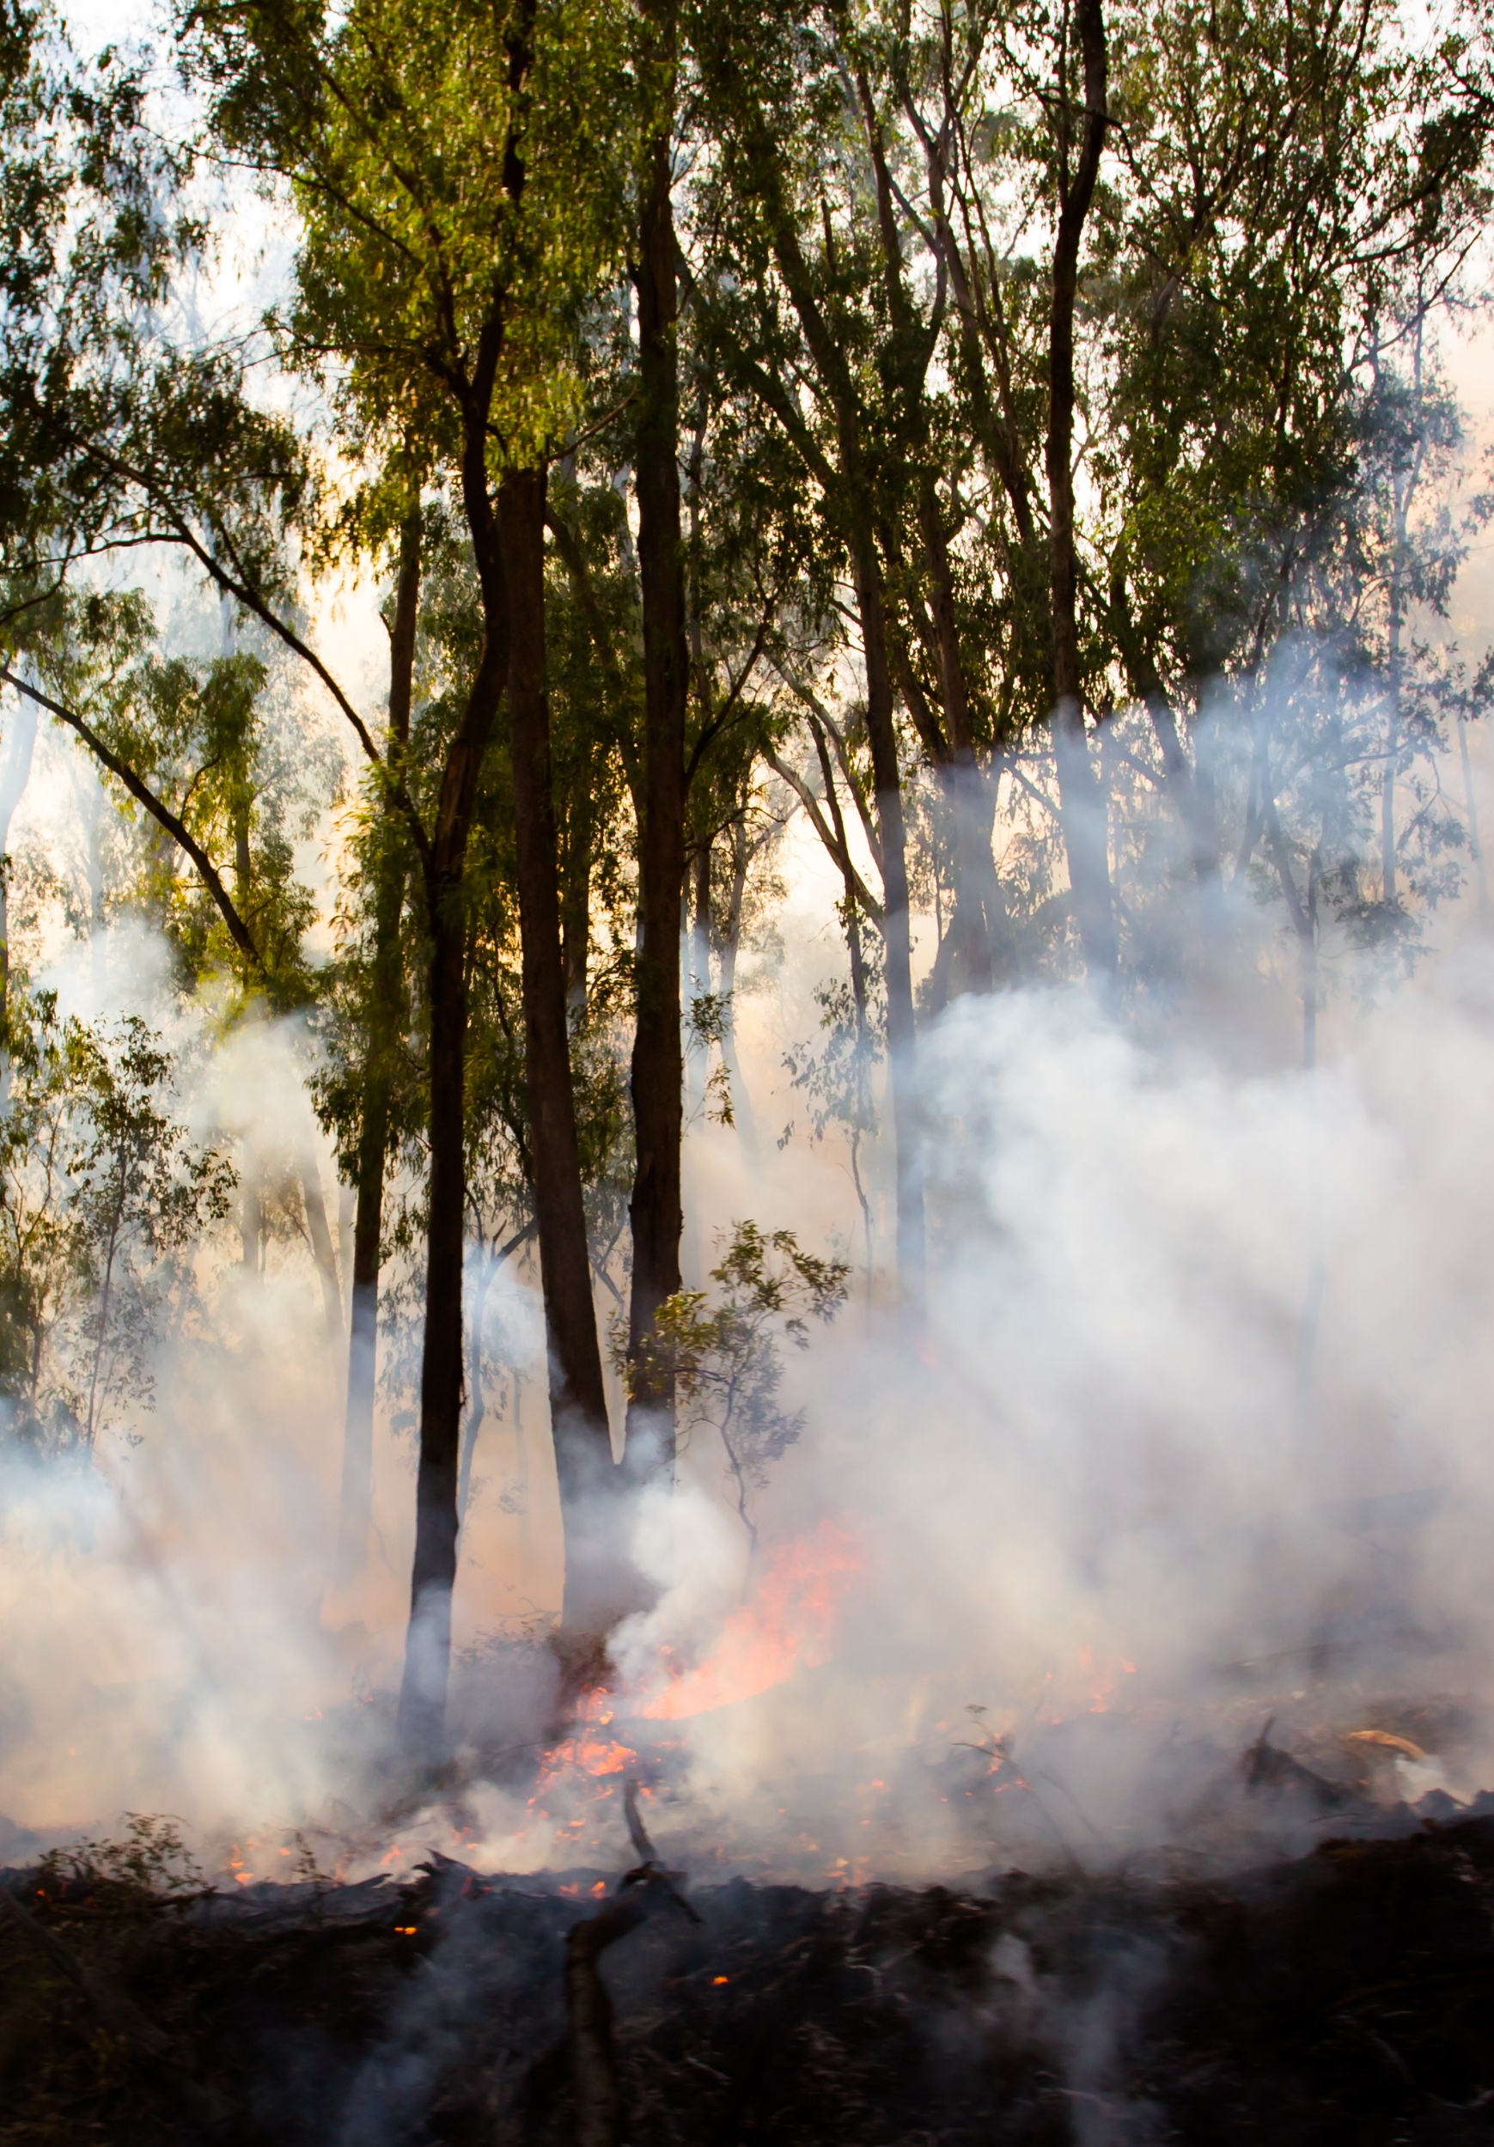
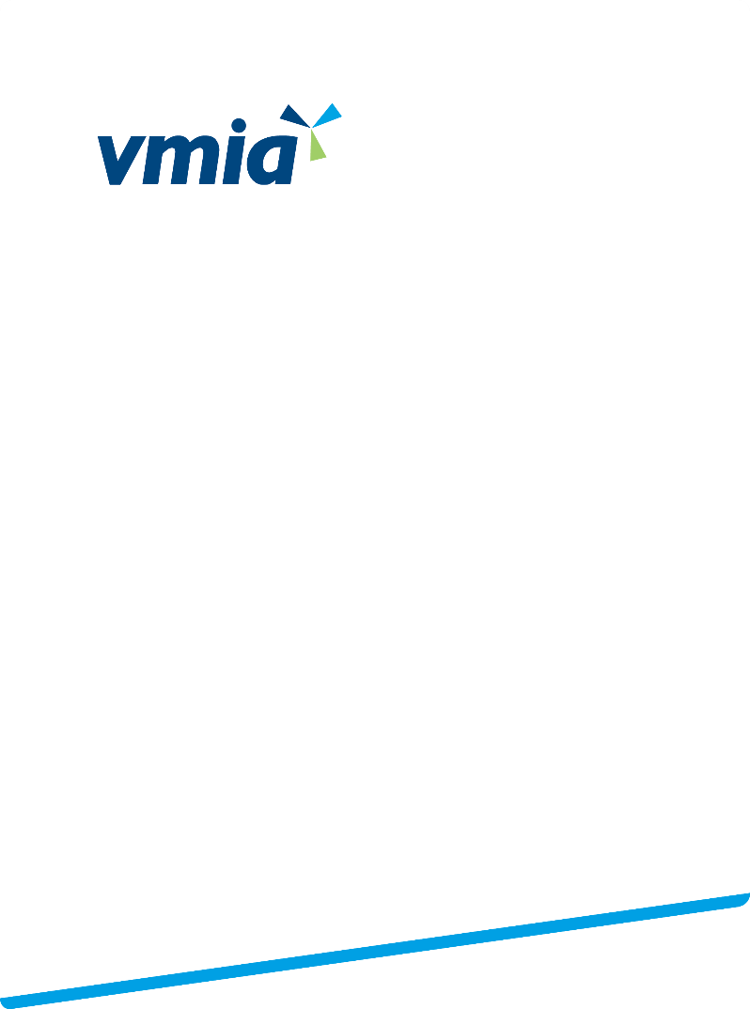
Risk Identification and Management Program (RIMP)
<Agency name>
Acknowledgement
This guide has been developed and prepared by the Victorian Managed Insurance Authority to support the delivery of the RIMP training program.
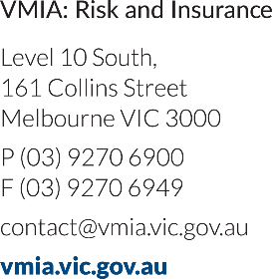 | © State of Victoria 2019  You are free to re-use this work under a Creative Commons Attribution 4.0 licence, provided you credit the State of Victoria (Victorian Managed Insurance Authority) as the author, indicate if changes were made and comply with the other licence terms. The licence does not apply to any branding, including Government logos.

Table of Contents
Introduction 4
Program benefits 4
Audience 4
Icon Key 4
Program overview 5
More information 5
Phase One: Risk Identification (or Review) and Analysis 6
Introduction 6
Preparation by the Facilitator 7
Prepared flip chart pages or A1 posters 7
Phase One Workshop 9
Section One: Introduction to risk concepts 11
Section Two: Identify risk categories and uncertainties 15
Section Three: Risk causes and impacts 17
Workshop close 19
Post Workshop 20
Phase Two: Risk assessment and treatment planning 21
Introduction 21
Preparation by the Facilitator 22
Phase Two: Risk assessment and treatment planning workshop 24
Section One: Identify controls 25
Section Two: Control Effectiveness 27
Section Three: Risk Rating 28
Section Four: Treatment Planning 29
Workshop Close 30
Post Workshop 31
Phase Three: Continuous Improvement 32
Introduction 32
Suggested actions 32
Appendix I – Prepare A1 Posters 33
Appendix II – Icebreakers 34
Ice Breaker 1 – Would you? 34
Ice Breaker 2 – Risk Management 34

Introduction
The Risk Identification and Management Program (RIMP) is designed to assist you identify and manage risk.
Because each phase of the RIMP program can operate independently, you are encouraged to tailor the workshops and activities to meet your needs and provide the most value to your organisation.

Program benefits
The Risk Identification and Management Program (RIMP) helps you build your risk management capability. It:
- Validates strategic objectives
- Identifies operational and strategic risks
- Defines risk treatment plans
- Builds risk capability of executives and/or board
- Can be tailored to meet your needs and risk maturity

Audience

Program
The audience of the RIMP program may include:
- Risk Managers and Owners
- Executive team
- Board members

Document
The audience of this document is the Risk Manager who will be running and facilitating the program.

Icon Key
Icon | Description | Icon | Description
 | Group Discussion | 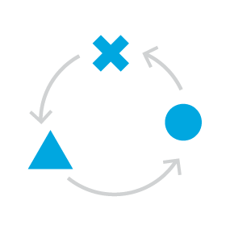 | Activity
 | Whiteboard / Flip Chart

Program overview
There are three phases in the RIMP program.

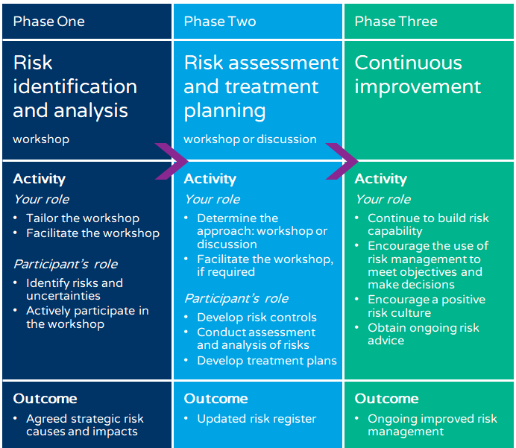

More information
You will find additional useful information in the Risk Guidance Materials :
- Risk Management Tools and templates: https://www.vmia.vic.gov.au/tools-and-insights/risk-management-tools

Phase One: Risk Identification (or Review) and Analysis

Introduction
This phase involves facilitating a workshop with the aim of summarising key risk themes or categories and identifying the causes and impacts of risk events.
You should tailor the content to suit the needs and risk maturity of your organisation.

Purpose
The purpose of this phase is for your senior leaders to agree on what might be preventing your organisation from meeting its objectives, and identifying the causes and impacts of the risks.

Objectives
By the end of this phase your participants will have:
- A standardised understanding of key risk concepts
- Identified risk events for each strategic objective and grouped them into categories
- Considered shared risk implications (optional)
- Identified causes and impacts for each risk event

Overview
Read through the content of each topic and tailor the workshop to your requirements and time availability.
Topic | Overview | Key resources required | Approx duration
Workshop opening | Introduce the content and icebreaker | Workshop slides | 10 mins
Risk concepts | Explain definition of risk and how to write a risk description (event, cause and impact) | Workshop slides | 40 mins
Risk categories and uncertainties | Facilitate discussion to identify or validate risk events for each strategic objective  Identify shared risk implications (optional) | Workshop slides  A1 posters/flipcharts with strategic objectives | 35 mins
Risk causes and impacts | Identify causes and impacts for each risk. | Workshop slides  A1 posters/flipcharts with strategic objectives | 20 mins
Workshop close | Summary and next steps | Workshop slides | 10 mins
 |  | Approx total | 2 hours

Preparation by the Facilitator

Preparation of materials
 | Actions | Resources
1 | Facilitator Guide  - Completely read through the speaker notes and instructions for the activities.  - Then modify this Guide to suit your needs:  - Add your organisation’s name to front cover and change image (optional).  - Delete any sections not required  - Modify the content and/or activities, if required | Facilitator Guide
2 | PowerPoint slides  - Read through the PowerPoint slides:  - Add your organisation’s name to first slide and change image (optional)  - Cross-reference them to the Facilitator Guide.  - Delete or modify the slides and/or images. | PowerPoint slides
3 | Prepare Strategic Objectives flip chart or A1 posters  - Obtain or identify your organisation’s:  - strategic objectives or focus areas  - projects and activities that enable your organisation to meet each objective.  - Prepare flip chart pages: see below.  or  - Arrange for A1 posters to be printed: see Appendix I | Flip chart and markers  or  A1 Posters

Prepared flip chart pages or A1 posters
See Appendix I: Prepare A1 Posters
Strategic Objective #1 | Strategic Objective #2 | Strategic Objective #3
Objective: xxx  Activities to achieve objectives:  Risks: | Objective: xxx  Activities to achieve objectives:  Risks: | Objective: xxx  Activities to achieve objectives:  Risks:

Resources checklist
Make sure you have the following resources ready before you start the workshop.
RIMP Facilitator Guide
RIMP Phase One workshop PowerPoint Slides
A1 posters or pre-prepared flip chart pages
Post-it notes
Flip chart paper and marker pens and/or whiteboard and pens
Blue-tac

Room set up
- Set the room in a U shape or café style
- Ensure that you have:
- Whiteboard and markers
- Flipchart stand, paper and markers
- Projector for the PowerPoint slides
- Check the projector is working and that nothing is obstructing the audience’s view
- Place markers and post-it notes on tables so that participants can use them during the workshop.

Phase One Workshop

Workshop Introduction
Time | Actions / Speaker Notes | Resources

Duration: 10 minutes
 | Display title slide as participants enter the room | 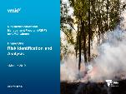
5 mins | Welcome participants  Introduce yourself
 | Opening  Set clear expectations for participants:  - What is RIMP  - Why is this workshop important/beneficial to them?  - How will you run the workshop? (process)  - Outcomes: what will you achieve at the end of this workshop?  Note: The outcomes may have been tailored depending on your needs. | 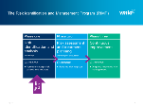  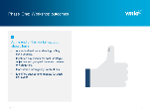
5 - 10 mins | OPTIONAL  Choose one of the activities from Appendix II – Icebreaker Activities.  Activity  Instructions  - Facilitate the activity as described in the appendix  - Watch the time as you can easily run over schedule.  - Use lots of energy to ensure that everyone is engaged. | 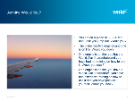
1 min | Introduce session  Talk through the topics to be covered in the session but do not go into detail at this point. | 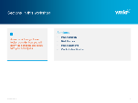

Section One: Introduction to risk concepts
Time | Actions / Speaker Notes | Resources

Duration: 40 minutes
 | Introduce section  Introduce the topics:  - Definition and types of risk  - Risk management  - The importance of risk culture  - Risk as an event, cause, impact and the Risk Bow Tie | 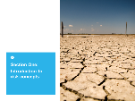
2 mins | What is risk?  - Display slide  Discussion:  - What else does risk mean to you?
3 mins | Benefits of risk management  Discussion:  - Why is it important to manage risk?  Reinforce:  - Risk management enables better decision making  - Good decisions lead to:  - outcomes/objectives being achieved  - better performance  - opportunities identified  - Risk management is not just identifying things that we should avoid | 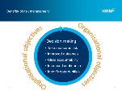
10 mins | Types of risk  - Risks can be divided into three types  - Transactional  - Operational  - Strategic  - As the senior management group, you are required to be aware of all three levels.  - However, the more time spent at the strategic level will help you to meet your strategic objectives.  Activity  Instructions  - Allow approximately 5 mins  - Write the three types of risk in columns or in a Y shape on the whiteboard or flipchart paper  - Ask participants to write an example of a risk on a post-it note and stick their example under the appropriate risk type  - As a group, discuss the responses. | 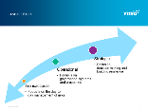  - Whiteboard or flip chart paper  - Markers  - Post-it notes  Transactional  Operational  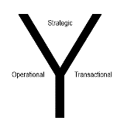
2 mins | Risk categories  Discussion:  Reinforce these common risk/opportunities categories (probably identified above):  - Do these categories apply to our organisation?  - Are there any we have missed in our objectives? | 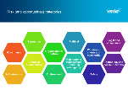
3 mins | Risk Governance (not used for health)  Discussion:  - Explain the five domains of governance model  - All domains revolve around the core business.  - Discuss how it can be used as a tool to ask questions about overall governance as well as risk governance. | 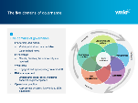
2 mins | Health specific  Patient Safety Themes  Discussion:  Discuss common patient safety themes in health services across the state. Focus is on patient at the centre of everything and the ‘patient voice’. | 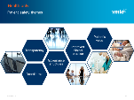
3 mins | Health specific  Clinical Risk Governance  Discussion:  - Discuss your clinical governance model. Key points include ‘safe, effective, person-centred care’ at the centre of the framework.  - Discuss how it can be used as a tool to ask questions about overall governance as well as clinical governance. | 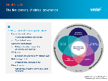
5 mins | Risk management process  - Risk management assists all points of strategic decision making, including risk appetite, risk assessment and controls and treatments  - Risk management is integral to effective corporate planning and corporate planning is integral to effective risk management  - They can be risks to strategy, or risks from strategy  Discussion:  Talk through the example and discuss:  - Identify strategic objectives:  - Need to consider many factors when preparing the strategy and objectives  - Risk appetite:  - Combination of opportunities and how much risk you are willing take  - Risk identification and assessment  - What are the causes that might impact meeting the objective?  - Controls/treatments:  - What actions have been taken to manage the risks?  - What actions can be taken to manage the risks?  - All risk management considerations feed back to strategic objectives and risks | 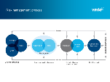  OR  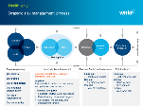  OR  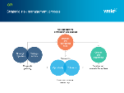
5 mins | Leadership and (risk) culture  - Importance of culture and risk culture to successfully implement risk management  - Positive risk culture starts at the top – that’s you!  - A positive risk culture is one where every person in the agency believes that thinking about and managing risk is part of their job. | 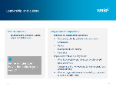
5 mins | Risk defined in event, cause, impact format  Tip:  When explaining Event, Cause and Impact, replace the example with one from your organisation.  - Explain  - Event (undesirable)  - Cause/trigger  - Impact/consequence  - We put them in a sentence that becomes a risk description for your risk register:  - Risk of [event] caused by [cause], resulting in [impact] | 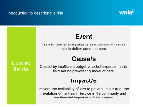
5 mins | Risk Bow Tie  Tip:  Use the scenario used in the Event/Cause/Impact example above to illustrate the Bow Tie Diagram and promote further understanding.  - The risk bow tie is another way of representing the relationship of Event, Cause and Impact.  - It is also useful in discussing different type of controls: Prevent vs Detect. Also treatments  - Talk through your Risk Bow Tie example  - Controls and treatments should also be recorded on the risk register | 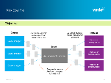  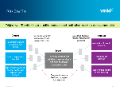

Section Two: Identify risk categories and uncertainties
Time | Actions / Speaker Notes | Resources

Duration: 35 minutes (including shared risk)
 | Preparation  Flipchart or posters  - Display the flipcharts/posters in sight of the participants | - Pre-prepared flipcharts or A1 posters  - Blue-tac
Introduce section
Introduce the topics:
- Validate strategic objectives
- Identify risk categories
- Identify uncertainties:
- Reasons for uncertainties
- Other considerations, including culture, shared risks, etc
10 mins | Validate your understanding of your strategic objectives  - Discuss and confirm the strategic objectives and activities  - Ensure there is alignment of understanding. If not, discuss possible amendments or suggest postponing the workshop until the objectives have been agreed.  - Do some of our strategic risks arise from uncertainty? What are we uncertain about? | Pre-prepared flipcharts or A1 posters
15 mins | Activity  Instructions  - Ask participants to use the post-it notes to write what is going to stop them achieving their objectives (ie. risks and uncertainties)  - Stick the post-it notes on the relevant objective poster  - As a group, group the risks/uncertainties into categories eg. financial, workforce, etc  Note: Re-display slide: Risk (and opportunities) categories  Debrief  - Discuss identified risks and categories  - Explain that the categories can then be used to:  - Logically categorise and consider them on the Risk Register  - Identify uncertainties  - Help write risk descriptions  - Help identify and allocate risk owners | Pre-prepared flipcharts or A1 posters  Post-it notes
10 mins | Shared risks (optional)  Discussion  For the same strategic risk discussed above, facilitate discussion to identify shared implications using the following questions:  - Is the risk new or emerging, or has it existed for some time?  - Do the actions of other agencies have a negative impact on the severity of this risk for you? Are there implications for your insurance programs?  - Could our preferred approach to addressing this risk have unintended negative consequences for other agencies?  - Which agencies do we need to consult and collaborate with?  - Who should liaise with the other agencies?  - Minister  - Portfolio Department  - Board  - CEO, Executive  - Manager  - Program lead  - Who should be the lead agency for this risk and what resourcing is required?  - How best can your agency contribute to the effective management and monitoring of this risk?  - Are we sure we’re collaborating effectively with the right people, at the right time?  Important  If the answer is yes to either question 2 or 3, then the strategic risk has shared implications. | Refer to:  VGRMF: shared and State Significant Risk Practice Notes

Section Three: Risk causes and impacts
Time | Actions / Speaker Notes | Resources

Duration: 20 mins
 | Introduce section  Introduce the topics:  - Risk descriptions  - Identify events, causes and impacts to develop risk descriptions | 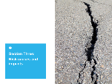
5 mins | Revisit risk descriptions  - Remind participants that to describe a risk, you need to identify:  - Event  - Cause  - Impact  Discussion  - Describing a risk can be challenging? Why?  Tip:  Challenge what the risk event is, as sometimes it can be confused with a cause.  - Why might it take multiple attempts and a lot of discussion to agree on what the risk actually is?  - Discuss the pitfalls in describing risks.  Don’t identify:  - risks as broad statements  - risks as a cause  - risks as incidents  - risk as consequences | 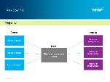
15 mins | Determine risk causes and impacts  Activity  Instructions:  - In small groups:  - Give each group some flip chart paper.  - Allocate one or two risks to each group  - Ask them to create three columns with the headings ‘Event’, ‘Cause’ and ‘Impact’ and ask each group to identify causes and impacts for each risk.  If applicable to your organisation:  - Group is to develop a full risk description  - Review with the rest of the group and reword if necessary to reach agreement.  - Risk descriptions are recorded on the Risk Register  Note:  Controls and treatments are discussed in Phase Two. | Flipchart paper and markers

Workshop close
Time | Actions / Speaker Notes | Resources

Duration: 10 minutes
5 mins | Review key points  Discussion  - Ask the group to share what they have learnt and key highlights about each topic. | 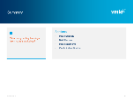  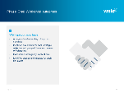
5 mins | Next steps  - Discuss next steps and actions

Post Workshop
Risk Manager to complete the following activities.
Step | Actions | Resources
1 | Summarise risk categories  Summarise risk categories and update risk register | Summary of categories
2 | Assist with risk descriptions  If required, work with VMIA to develop risk descriptions and update risk register | Develop risk descriptions
3 | Keep all posters/flipcharts for Phase Two | Posters/flipcharts

Phase Two: Risk assessment and treatment planning

Introduction
The Risk assessment and treatment planning phase can be conducted as a second workshop or discussed in meeting/s with key stakeholders.
The workshop or discussions will help your organisation:
- identify risk controls and treatments and assess their effectiveness
- rate the risks
- develop treatment plans

You should tailor the content to suit the needs and risk maturity of your organisation.

Purpose
The purpose of this phase is for your senior leaders to assess the risks on your risk register and develop appropriate controls and treatments.

Objectives
By the end of this phase, the participants will have:
- Identified controls and treatments with control owners.
- Rated the effectiveness of controls, using their control effectiveness rating criteria.
- Rated overall risk using their likelihood and consequence matrix.
- Identified treatment plans

Overview
Read through the content of each topic and tailor the workshop to your requirements and time availability.
Topic | Objective | Resources required | Approx duration
Workshop introduction | Revise Phase One and introduce the workshop | Workshop slides | 5 mins
Control identification | Facilitate activity to identify controls for each risk. | Workshop slides  A1 posters from Phase 1  Risk Bow Tie A1 posters | 30 mins
Control effectiveness | Rate control effectiveness of each control identified. | Your organisation’s control effectiveness rating criteria | 20 mins
Risk rating | Rate likelihood and consequence to arrive at an overall risk rating. | Your likelihood and consequence criteria  Your risk assessment matrix | 20 mins
Treatment planning | Identify and develop treatment plans for each risk identified | Your risk treatment prioritisation criteria | 20 mins
Workshop close | Summary and next steps | Workshop slides | 10 mins
 |  | Approx total | 1 hour 45 mins

Preparation by the Facilitator

Documents required
Before the workshop:
- Locate the following documents:
Control effectiveness rating criteria
Likelihood and consequence table
Risk assessment matrix
Note: If you don’t use these tools, please refer to VMIA’s Risk Management Tools on the VMIA website and intranet site:
- B2 Risk Criteria Examples
- B4 Guide to Monitoring and Reviewing Risks
- Review the documents so that you are familiar with the content
- Print a copy of each document, one per person (or small group)

Pre-prepared flipcharts or posters of the Risk Bow Tie (one per group)
See:
- Appendix II: Prepare A1 Posters
- Soft copy of this diagram: RIMP Risk Bow Tie template.pptx
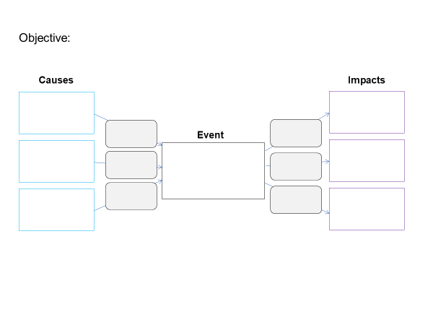

Resources checklist
Make sure you have the following resources ready before you start the workshop.
RIMP Facilitator Guide
RIMP Phase Two workshop PowerPoint slides
The A1 posters or pre-prepared flip chart pages used in Phase One
A1 posters or pre-prepared flip chart pages of Risk Bow Tie diagram above – one per group
Post-it notes
Marker pens
Blue-tac

Phase Two: Risk assessment and treatment planning workshop

Workshop introduction
Time | Actions / Speaker Notes | Resources

Duration: 5 minutes
 | Display title slide as participants enter the room
1 min | Welcome participants  - Introduce yourself if necessary  - Participants to introduce themselves if necessary
3 mins | Revise Phase 1  Open the workshop:  - Where we are up to in the overall framework  - Revise key points from Phase 1 | 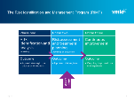
1 min | Introduce session  - Outcomes: what will you achieve at the end of this workshop?  - Talk through the topics to be covered in the session but do not go into detail at this point. | 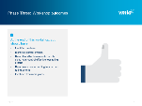  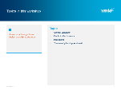

Section One: Identify controls
Time | Actions / Speaker Notes | Resources

Duration: 30 minutes
Introduce topic
- Identify controls for each risk
- Identify control owners
3 mins | What is a control?  Discussion  - Write ‘What is a control?’ at the top of a flip chart and facilitate the discussion before revealing your definition on the slide  Explain  - A control is a measure or action to modify identified risks now  - Controls include legislation, processes, policies, practices or other actions which modify risk.  - Business Continuity Planning for disruptive events is also a form of control  - Controls may not always exert the intended or assumed modifying effect.  - Controls must be regularly evaluated to determine or validate effectiveness  - Understanding the control environment is essential part and the risk owner is the best person to do this. Specialist expertise may also be used. | 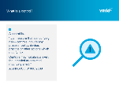  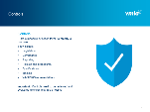
2 mins | Control owners  - When identifying owners for your controls, consider:  - Area involved in the control  - Expertise  - Accountability for mitigating and managing the risk
25 mins | Determine controls and control owners for identified risks  Activity  Instructions  - Form small groups  - Give one A1 poster or flipchart (risk poster) from Phase 2 to each group  - Give one blank Risk Bow Tie poster to each group  - Each group to identify possible controls and an owner for each control for their allocated risk  - Record controls on the Risk Bow Tie poster  - Display posters using blue-tac  - As a whole group, discuss controls and modify controls and owners if required.  - Record final controls and owners with marker pens on the posters | 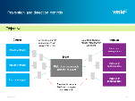  - A1 posters or flip chart from Phase 2  - A1 posters or flipcharts: Risk Bow Tie  - Marker pens  - Blue-tac

Section Two: Control Effectiveness
Time | Actions / Speaker Notes | Resources

Duration: 20 minutes
 | Introduce topic | 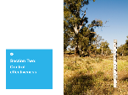
5 mins | Definition of control rating  Discussion:  - Discuss what a control rating is  - Once you have briefly discussed the group’s ideas, reveal the definition  Discussion:  - Discuss methods to assess the effectiveness of controls | 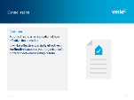  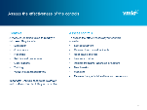
15 mins | Asses control effectiveness using your control effectiveness rating criteria  Activity  - Distribute:  - your control effectiveness rating criteria  - or VMIA’s B2 Risk Criteria Examples and B4 Guide to Monitoring and Reviewing Risks tools  - Refer to the controls listed on the risk poster from the previous activity  - In small groups, discuss:  - Possible evaluation methods  - The effectiveness rating of the agreed controls | - A1 posters or flip chart from Phase 1  - Post-it notes  - Marker pens

Section Three: Risk Rating
Time | Actions / Speaker Notes | Resources

Duration: 20 minutes
 | Introduce topic | 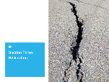
5 mins | Definition of Risk Rating  - Discuss definition of a risk rating.  - What makes it difficult to rate risks? Can be difficult to assess likelihood and consequences  - Controls influence how a risk is rated. A risk may be rated high or low based on the control effectiveness, or in the absence of a control. | 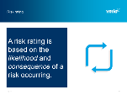
15 mins | Assess likelihood and impact of risk  Activity  - Distribute your:  - Likelihood and consequences criteria  - Risk assessment matrix  - Or VMIA’s B3 Risk Assessment Treatment Guide  - In the same small groups as previously:  - Refer to the risk posters  - Assess the risks according to their risk rating criteria | 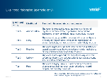

Section Four: Treatment Planning
Time | Actions / Speaker Notes | Resources

Duration: 20 minutes
 | Introduce topic
5 mins | Definition of treatment planning  Discussion:  - Facilitate a discussion about what treatment planning is ie. ‘a shopping list’ of what needs to be done  - Examples of treatment plans | 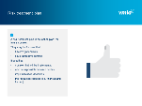  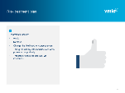
15 mins | Identify a treatment plan  Activity  - In small groups, identify any risks/causes that haven’t got controls, or the controls need to be improved  - Develop a treatment plan to include:  - What will be done  - Who will do it  - When it will be done  - What resources are required to implement the plan  - Prioritise the treatments | Flipchart paper

Workshop Close
Time | Actions / Speaker Notes | Resources

Duration: 10 minutes
5 mins | Review key points  Discussion  - Ask the group to share what they have learnt and key highlights about each topic. | 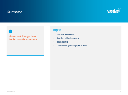
5 mins | Next steps  - Discuss next steps and actions

Post Workshop
Risk Manager to complete the following activities.
Step | Actions | Resources
1 | Update risk documents  Make updates to risk register and other documents:  - control effectiveness matrix  - likelihood and consequence table  - treatment plans | Risk documents

Phase Three: Continuous Improvement

Introduction
As part of your risk role, you are probably responsible for improving and/or maintaining the risk capability of your organisation.
You should notice changes in the risk behaviours and risk management of your organisation after participating in the RIMP program. And there are other actions you can take to embed risk in your organisation’s culture, aid continuous improvement and decision making to help meet strategic objectives.

Suggested actions
This is not an exhaustive list of actions you can take to build or improve your organisation’s risk capability:
- Learn more from your VMIA Risk Adviser
- Regularly review your organisation’s risk tools, actions and arrangements to ensure they still help meet your organisation’s objectives and lead to better decision making
- Complete VMIA’s Risk Maturity Benchmark self-assessment tool:
- https://www.vmia.vic.gov.au/tools-and-insights/risk-maturity-benchmark
- Consider attending public or other customised programs offered by VMIA: https://www.vmia.vic.gov.au/learn/upcoming-programs:
- Refer to VMIA’s Risk Management and Insurance tools for guidance to developing or improving your risk and insurance documents

Appendix I – Prepare A1 Posters
Step | Action
1 | For Phase One:  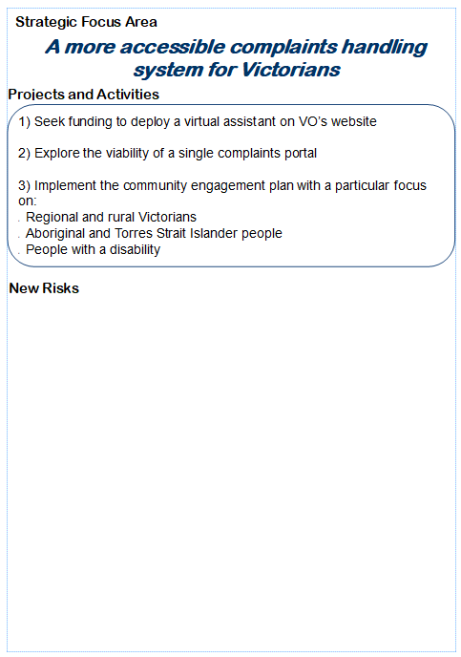  - Create A1 posters that outline:  - your organisation’s strategic objectives or focus areas  - the projects and activities that will enable your organisation to meet the objective.  - Each strategic objective should correspond to one A1 poster. See example (right)
2 | - Use Word or PowerPoint to create your posters
3 | - Arrange to have the posters printed, as per your organisation’s policy.

Appendix II – Icebreakers

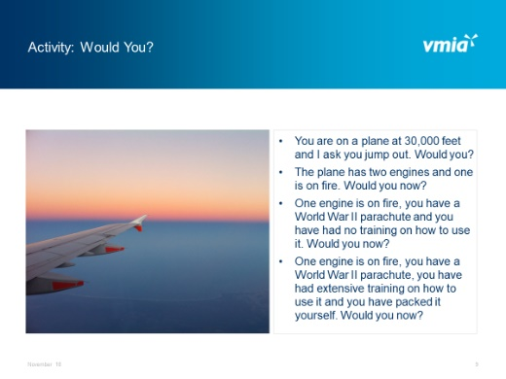
Ice Breaker 1 – Would you?
Instructions:
- Click to display each question on the slide
- Allow time between each question for short discussion.
- You are on a plane at 30,000 feet and I ask you jump out. Would you?
- The plane has two engines and one is on fire. Would you now?
- One engine is on fire, you have a World War II parachute and you have had no training on how to use it. Would you now?
- One engine is on fire, you have a World War II parachute, you have had extensive training on how to use it and you have packed it yourself. Would you now?
Note: If still ‘no’ responses – ask why?

Debrief:
This demonstrates:
- Different tolerance levels
- Need to understand the context internally and externally
- When is enough information enough?
- Need to consult subject matter experts

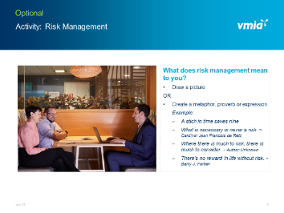
Ice Breaker 2 – Risk Management
This is a short activity. If there is a drawing wall use it, if not, stick up several pieces of blank flipchart paper and get participants to stand up.
Instructions:
Ask participants to:
- Take three minutes to create a metaphor, saying, proverb or draw a picture that describes what risk management means to them.
- Draw / write up the best ideas on a flipchart page or the whiteboard.

Debrief:
- Try to draw out particular themes.
- Highlight ideas which really resonate with risk management and decision-making.

