A6 Articulate Risk
Appetite & Tolerance

Purpose and Outcomes

This guide includes questions, considerations and supporting material which will help you to articulate your risk appetite and tolerance.
The information in this guide will support you in considering the key components of your Risk Appetite and Tolerance.
Context
The purpose of risk management is to add and protect value. Articulating risk appetite is a part of informed decision making. The diagram on Page 3 highlights the centrality of this. Articulating risk appetite also provides freedom within boundaries

Boards/Executive and those who set the strategic direction articulate and review risk appetite and tolerance when required. This may be when there is a:
- Change in Board or Executive
- Material change to purpose of organisation (expansion, contraction, merger / acquisition)
- Change to strategy
- Scheduled review

Risk appetite and tolerance can be applied to:
- Strategic direction setting
- Critical / material decision making.

Supporting Documents
    - Victorian Government Risk Management Framework (VGRMF) Practice Guide (2/ 16 - V3)
Risk Management Glossary
Term | Definition
Key performance indicator (KPI) | A measurable value that demonstrates how effectively a company is achieving key business objectives. Organizations use key performance indicators at multiple levels to evaluate their success at reaching targets.
Key risk indicator (KRI) | A key risk indicator is a lead indicator that identifies whether the likelihood of a risk event occurring is increasing or decreasing.
Risk | The effect of uncertainty on objectives.
Risk appetite | The amount and type of risk that an organisation is willing to pursue or retain.
Risk tolerance | The agency’s readiness to bear the risk after risk treatment in order to achieve objectives. Risk tolerances are based on the maximum level of acceptable risk and may be expressed in various ways depending on the nature of the risk.
Strategic direction | Vision or goals for the future.
Strategic plan | Articulation of how to achieve strategic direction.

Instructions
- Use this guide to inform you when defining your risk appetite and tolerances.
- Use the considerations and questions to inform the structure of your risk appetite and tolerance.
- Use the examples to help guide the structure of your risk appetite and tolerance.
- Delete pages 1-3 and use your own organisation’s logo, branding and style on the remaining pages.

Considerations and Questions

It is important to consider your readiness, application and embedding of articulating your risk appetite and tolerance. The following considerations and questions will assist in this process.
- Consideration | - Questions to ask
Readiness | Do we have the desire and willingness to articulate our risk appetite and tolerance?
Readiness | Does the Board and the CEO agree there is a need to articulate our risk appetite and tolerance?
Readiness | Is our Strategic direction up to date?
Readiness | Is our Strategic Plan up to date?
Readiness | How will we use our risk appetite statements?
Communication and embedding | How will we communicate our risk appetite and tolerance to the organisation?
Monitoring | How will we monitor the currency of our risk appetite and tolerance statements?
Monitoring | How will we know our risk appetite and tolerance statements are performing?
Amount of risk | How much risk can we afford to take on, based on the anticipated gain?
Decision making | Are we making defensible decisions?
Decision making | Are we making decisions based on the best available information?
Decision making | Are we making decisions consistent with our ethics and values?
Decision making | Are we making future facing decisions?

Where does risk appetite and tolerance fit into Risk Management?
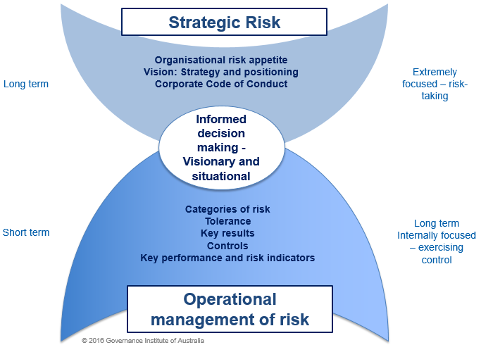
Long term Internally focused – exercising control
Short term
Long term
Externally focused – risk-taking
This diagram highlights centrality of informed decision making.
Risk appetite is located at the strategic level.
Risk tolerance is located at the operational level.

Example 1 Risk Appetite Statement
Overall Risk Appetite
We want everyone to take responsibility for the management of risk in our organisation. Specifically, we are willing to engage with higher levels of risk where the outcomes would benefit our clients. Conversely, we have little to no appetite for engaging with risk that could harm our clients.
Corporate objective | Risk category | Risk appetite statement | Source / Indicator | Risk tolerance range
 |  |  |  | Acceptable | Tolerable | Unacceptable
Become an employer of choice in our sector | Financial | A cautious appetite for financial volatility and desire to carefully control costs.  We operate within the approved budget expenditure limit of ≤5.0%. | Annual board approved budget | 1.0% – 2.5% | 2.5% – 5.0% | >5.0%
 | Human Resources | An accepting appetite for applying new approaches to ensure we remain an employer of choice in our region, while maintaining safety and service levels.  We will do this by:  • maintaining an annualised staff turnover rate of 15% or less over a rolling 12-month period.  • ensuring our rate of staff absenteeism remains at ≤3% in each month.  • less than five accepted workers’ compensation claims annually. | Median staff initiated turnover rate for public sector agencies | ≤15% | 15% – 17% | ≥17%
 |  |  | VPS benchmark | <3.0% | 3.0% – 5.0% | > 5.0%
 |  |  | 2019 sector benchmark | <5 | 5 –7 | >7
 | Service Delivery | A cautious appetite to lose a valued position of trust with our clients.  We will maintain a level of client engagement of at least 85%. | Board-approved minimum level | ≥85% | 75% – 80% | ≤75%
 | Projects | An accepting appetite to innovate through projects and R&D  to benefit our clients.  We accept that 10% of project effort may not result in immediate or direct client benefits as long as lessons are learned for future services and products. | Annual board approved budget | ≥10% | 10% – 20% | >20.0%
 | Information Management & Legal Compliance | A very controlled appetite for information security breaches, frauds or proven ethical complaints.  We maintain a zero tolerance for such events. | Government Information Security Policy Standard, Compliance Standard | 0 instances |  | 0 instances

Example 2 Risk Appetite scale and definitions

Controlled (little-to-none) | Cautious (low) | Accepting (medium) | Open (high)
Avoidance of risk is the main treatment | Prefer safe options with little risk of adverse exposure for department and/or the government | Willing to consider all options and choose the one that is most likely to result in successful delivery while also providing a reasonable degree of the protection from high risks | Eager to engage with risks and opportunities when the potential benefit is great.
(Adapted from: Department of Health, Enterprise Risk Appetite)

